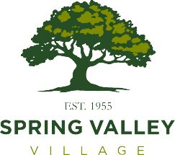

Public Meeting – Brighton Place Paving and Utility Improvement Project
The City of Spring Valley Village will host a public meeting on Tuesday, March 5, 2024, to provide an overview of the project, which includes replacement of streets, water, sanitary sewer and storm sewer in the Brighton Place Subdivision. The design firm, Cobb, Fendley & Associates; project contractor, Conrad Construction; and Spring Valley Village City Staff will be present to discuss the parameters for the project, residents in attendance will have an opportunity to ask any questions they may have concerning the project.
Topics that will be covered in the overview include:
- Overview of the Project
- Traffic Control Plan
- Spring Valley Village Right-of- Way Policy
Date: Tuesday, March 5, 2024
Time: 6:00 p.m. – 7:00 p.m.
Location: City Hall Council Chamber, 1025 Campbell Rd.

For more information, please contact Public Works Director Kristina Watson by email to kwatson@springvalleytx.com or by phone at (713) 465-8308.

